**SEMESTER TRAINING REPORT**

on

**College Administration System**

***Submitted in partial fulfillment of requirements***

***for the award of the degree***

***Bachelor of Technology***

***In***

**Computer Science and Engineering**

To

**Punjab Technical University, Jalandhar**

**SUBMITTED BY: Under the guidance of Name: NIKHIL SRIVASTAV Mr. Sachin Bhardwaj**

**Roll no: 1802128**

**Semester: 8th**

**Batch: 2018-22**



**DEPARTMENT OF COMPUTER SCIENCE AND ENGINEERING**

**Chandigarh Engineering College –Landran**

**Mohali, Punjab - 140307**

**CERTIFICATE**

This is to certify that Mr. / Ms.___________________________ has partially completed / completed / not completed the Semester Training during the period from_______ to_______ in our Organization / Industry as a Partial Fulfillment of Degree of Bachelor of Technology in Computer Science & Engineering.

**(Signature of Project supervisor)**

**Date: ____________________**

**DECLARATION (16 Times New Roman)**

I hereby declare that the Project Report entitled ("College Administration job") is an authentic record of my own work as requirements of 8th sem academic during the period from **11th February,2022 to 15th June ,2022** for the award of degree of B. Tech. (Computer Science & Engineering, **Chandigarh Engineering College** under the guidance of (Mr.Sachin Bhardwaj).

**(NIKHIL SRIVASTAV)**

**Date: (1802128)**

Certified that the above statement made by the student is correct to the best of our knowledge and belief.

**Signatures**

**Examined by:**

1. 2. 3. 4.

**Head of Department**

**(Signature and Seal)**

**ACKNOWLEDGMENT**

I take this opportunity to express my sincere gratitude to the Director- Principal Dr. Rajdeep Singh Chandigarh Engineering College, Landran for providing this opportunity to carry out the present work.

I am highly grateful to the Dr. Sukhpreet Kaur HOD CSE, Chandigarh Engineering College, Landran (Mohali). I would like to expresses my gratitude to other faculty members of Computer Science & Engineering department of CEC, Landran for providing academic inputs, guidance & Encouragement throughout the training period. The help rendered by **Mr. Rajeev Sharma**, Supervisor for Experimentation is greatly acknowledged. Finally, I express my indebtedness to all who have directly or indirectly contributed to the successful completion of my software training.

**CONTENT**

|  |  |  |
| --- | --- | --- |
| **Sr.No** | **TITLE** | **PG. No** |
| **1.** | **Acknowledgement** |  |
| **2.** | **Introduction** |  |
| **3.** | **Student declaration** |  |
| **4.** | **Job role, About company** |  |
| **5.** | **Power Platform Fundamentals** |  |
| **6.** | **Projects Undertaken** |  |
| **7.** | **Microsoft Azure AI** |  |
| **8.** | **Mini Projects** |  |
| **9.** | **Conclusion** |  |
| **10.** | **Bibliography** |  |

**ACKNOWLEDGEMENT**

First and foremost, praise and thank God, the Almighty, for His blessings throughout my work to develop this completely.

Then, I would like to express my gratitude to My Manager, Mentor and colleague,

My teachers in Chandigarh group of colleges for all their suggestions and constant support during this. Their valuable guidance and encouragement throughout the period were critical factors which contributed towards development of mine.

Through their untiring efforts, they helped me to critically analyze the problems in a systematic manner and consider innovative approaches to evolve practical solutions to develop models.

It was a great privilege and honor to work and study under their guidance. I am extremely grateful for what they have offered me. I would also like to thank them for their friendship and empathy.

I am extremely grateful to my parents for their love, prayers, care and sacrifices for

educating and preparing me for my future. Also, I express my thanks to other teachers and mentors for their support and valuable contributions.

I express my sincere gratitude to Dr. Sukhpreet Kaur, HoD in Department of CSE, CEC-CGC, Landran for her stimulating guidance, continuous encouragement.

This is to certify that the above statement made by the candidate is correct to the best of my/our knowledge.

**Mr. Sachin Bhardwaj Nikhil Srivastav**

**Asst.Professor 1802128**

**SEMESTER: 8**

**INTRODUCTION**

For years, Microsoft's Power Platform (including Power BI, Power Apps, Power Automate, and now Power Virtual Agents) existed under Dynamics 365. Any certifications that included these tools did so in an exclusively supporting role, despite their widespread (and increasing) popularity. The relatively recent Microsoft Certified: Power Platform Fundamentals certification is the tech giant's first attempt to draw these tools out and give them their own focus, highlighting how useful they are for numerous business applications.

Why we should do pl900?

* Describe the business value of Power Platform (15-20%)
* Identify the core components of Power Platform (15-20%)
* Demonstrate the capabilities of Power BI (15-20%)
* Describe the capabilities of Power Apps (15-20%)
* Demonstrate the capabilities of Power Automate (15-20%)
* Demonstrate the business value of Power Virtual Agents (10-15%)

Power platform fundamentals have advantage over other products as this is no low code platform people new to this domain can code easily, one does not need to be a hard coder to do this and then we started delivering pl900 course to help people all across the globe to implement this in their business needs and day to day solutions.

**Student Declaration to whomsoever, it may concern**

I, NIKHIL SRIVASTAV, 1802128 hereby declare that the work is done by me in ― Koenig solutions pvt.Ltd. I work here as a Corporate Trainer Training and teaching on various technology, from Dec 2021 till date, work for the partial fulfilment of the requirements for the award of the degree, B.E. Computer Science and Engineering.

I am a certified Microsoft Power platform fundamentals trainer as I cleared exam pl900 that is required for Microsoft power platform fundamentals and to be recognized as certified.



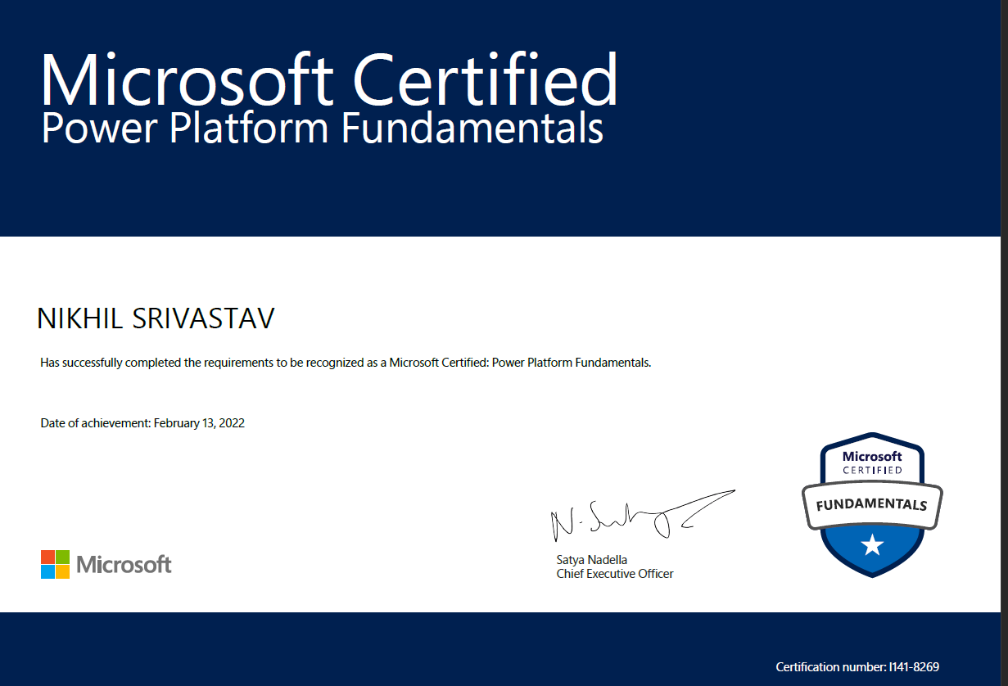

**Job role: -Technical Corporate Trainer**

🡪Who is a Corporate Trainer?

Simply, they are experts responsible for the career development of professionals. However, more broadly, their responsibilities and roles are pretty spread-out. They are career coaches, course & content developers, and employee performance analysts.

**Skills required to become a corporate trainer: -**

* Leadership development
* Communication
* Conflict resolution
* Emotional intelligence
* Presentation
* Relational and group dynamics
* Productivity and time management
* Influence (the ability to persuade)
* Customer service
* Business ethics

Responsibilities of a Corporate Trainer

**Assess training requirements of employees**: The first role of this job is to act as an analyst who assesses all the lacks in the working ecosystem of a company.

**Design and review training content**: Secondly, they design specialized training programs with specific content targeting the issue areas. This particular aspect of the job requires these professionals to also be experts as course creators.

**Conduct training programs**: Thirdly, a bit more obvious, trainers have to conduct the training programs and deliver the courses effectively in order for the learning employees to fully grasp the knowledge.

**Evaluate and update**: Finally, the effectiveness of any program rests on its ability to thoroughly review and revise itself. It is crucial as a trainer and content creator that one seeks feedback. Feedback drawbacks in the programs.

## **About Koenig Campus**

Koenig Campus Delhi is the world's largest IT training center with 80 classrooms and 30 testing stations. This modern facility also has in-house shopping, coffee islands, reflexology center, and a travel desk to cater to all possible needs of students, in addition to their educational requirements. Koenig's Delhi Centre is the largest Prometric and VUE testing center in India.

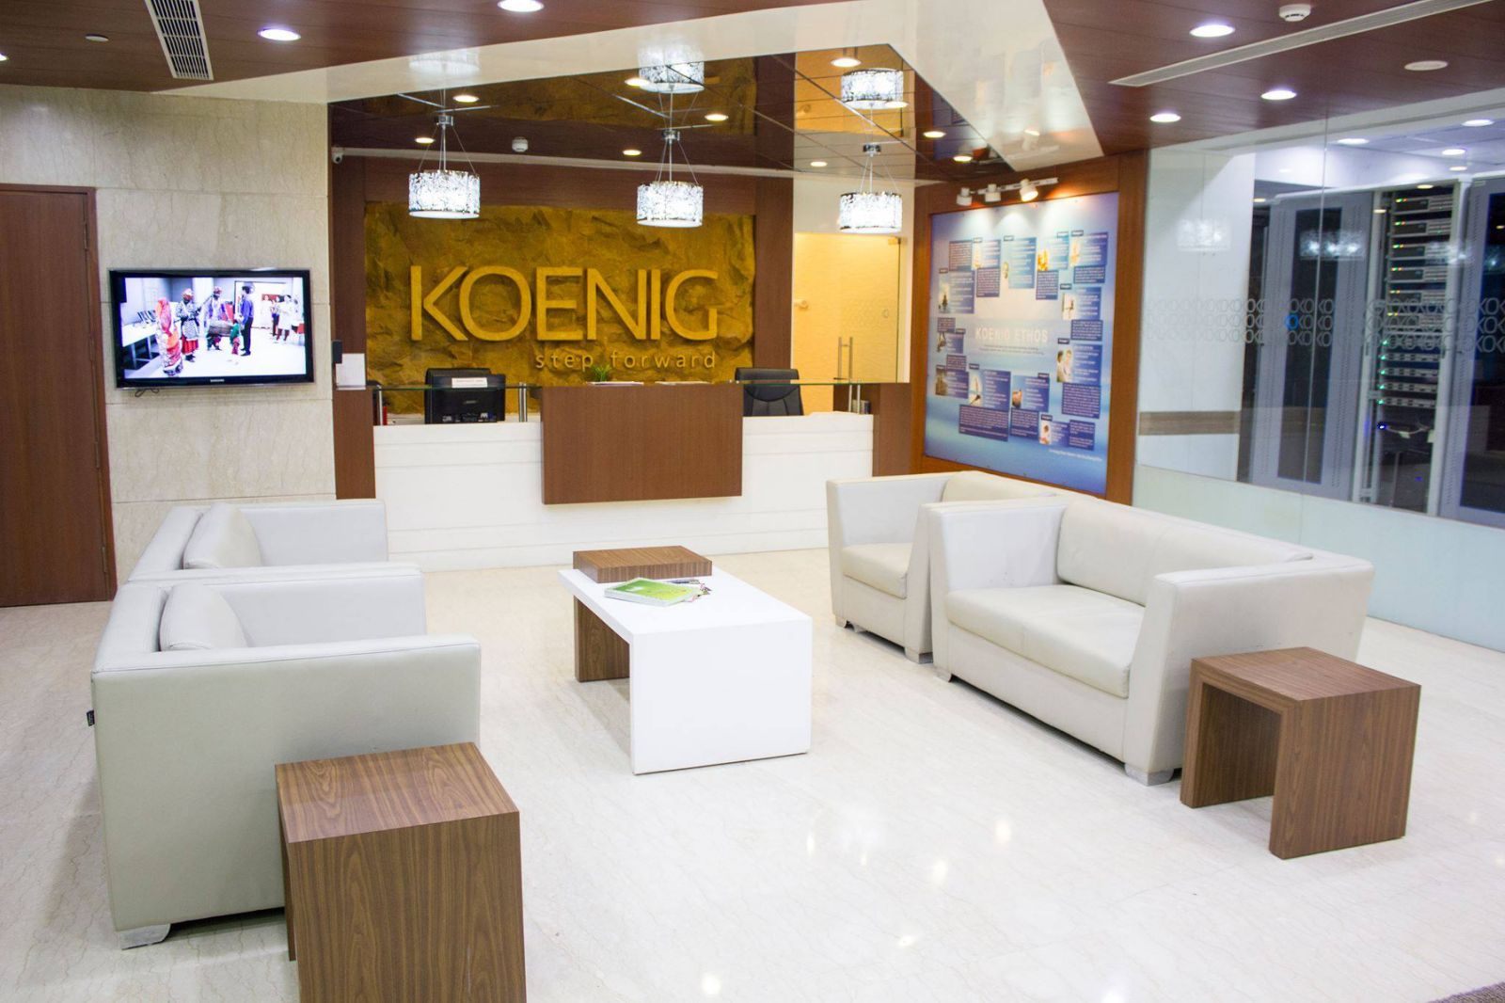

## **A Global Leader in IT Training**

Established in 1993, Koenig is one of the trusted IT training organizations in the world. Koenig is present in all continents except South America and Antarctica. Koenig has offices in USA, Canada, UK, Netherlands, South Africa, Dubai, India, Singapore, Australia and New Zealand. Our vision is to create a more just and prosperous world through education.

Koenig can help you grow your training business.

Koenig has 200 in-house trainers for Microsoft, Cisco, VMware, AWS, Oracle, Citrix, Red Hat. Koenig Trainers possess the mandatory certifications MCT, VCI, AAI, RHCI, CCSI etc.

We support some of the biggest training organizations all over the world.

### **Why Koenig?**

* Ready availability even at the short notice.
* Quality guaranteed.
* Serving all time zones.
* Quick response.
* We find trainers for [rare courses.](https://www.koenig-solutions.com/rare-courses)
* Peace of Mind!

**Our Top Differentiator**

* Quality of Trainers
* Best place to work for Trainees since 2010
* We are proud of our trainers

Platforms worked on: -

I have worked on various platforms starting from Koenig LET portal to Microsoft on24, Pearson vue Microsoft teams, Microsoft cloud learn on demand etc.

I am part of Koenig batches delivery in every mode and conducted successful training deliveries

* [Live Online](https://www.koenig-solutions.com/live-virtual-class-room)
* [1-on-1TMTraining](https://www.koenig-solutions.com/one-on-one-training)
* [Flexi](https://www.koenig-solutions.com/recording-of-live-online-training)
* [Classroom / Destination Training](https://www.koenig-solutions.com/destination-training)
* [Fly-me-a-Trainer](https://www.koenig-solutions.com/fly-me-a-trainer)
* [Hire Koenig Trainers](https://www.koenig-solutions.com/hire-koenig-trainers)
* [Topic Based Training](https://www.koenig-solutions.com/topic-based-training-course)

**Software Requirements**

**“MICROSOFT POWER PLATFORM”**

**Welcome to your Power Platform Training**

Welcome to PL-900, Microsoft Power Platform Fundamentals. This course will provide an overview of Power Apps, Microsoft Data verse, Power Automate, Power BI and Power Virtual Agents and lead learners through building basic apps, flows, a dashboard, and a Chatbots.

This course will cover the following topics:

* Business Value and use cases of Microsoft Power Platform
* Demo walkthroughs of key features in Power Apps, Power Automate, Power BI and Power Virtual Agents
* How to create basic apps with Power Apps, basic flows with Power Automate, a basic Dashboard with Power BI and a basic chatbots with Power Virtual Agents.

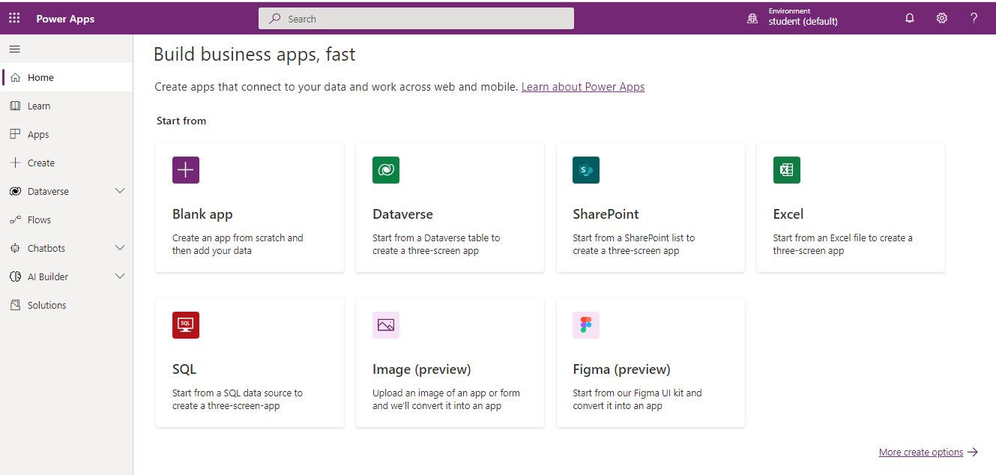

**What is Microsoft Power Platform?**

Microsoft Power Platform is comprised of four key products: Power Apps, Power Automate, Power BI and Power Virtual Agents.

**Why we need Microsoft power platform?**

Modern businesses run on data. Users interact with data daily from entering their time for payroll, seeking guidance on existing processes, and analyzing data to make decisions. In our technology driven world, users can be empowered to gain insights from and interact with data all while automating those menial responsibilities that seem to be more burden than job task. Microsoft Power Platform enables your business to craft solutions while empowering you to unite customized technology to help everyone, from the CEO to the front-line workers, drive the business with data.

**Features**

Among the programs listed above, there are cross cutting features which enable Microsoft Power Plat­form to be leveraged to its full potential. Some of these are:

**AI Builder** lets users and developers add AI capabilities to the workflows and Power Apps they create and use. AI Builder is a turnkey solution that allows you to easily add intelligence to your workflows and apps and predict outcomes to help improve business performance without writing code.‍

**Microsoft Data verse** is a scalable data service and app platform which lets users securely store and manage data from multiple sources and integrate that data in business applications using a common data model to ensure ease and consistency to users. Microsoft Data verse is the common currency that enables the components of Microsoft Power Platform to work together. It’s the foundation that enables the consoli­dation, display, and manipulation of data.

**Connectors e**nable you to connect apps, data, and devices in the cloud. Consider connectors the bridge across which information and commands travel. There are more than 275 connectors for Microsoft Power Platform, enabling all of your data and actions to connect cohesively. Examples of popular connectors include Salesforce, Office 365, Twitter, Dropbox, Google services, and more.

Although every feature is essential to building powerful solutions, let's dive in deeper to one of the features of Microsoft Power Platform, **connectors.**

**Data connectors**

Microsoft Power Platform is made powerful by its ability to leverage data across many platforms. To do this, components of Microsoft Power Platform use connectors. You can think of connectors as a bridge from your data source to your app or workflow which allows information to be conveyed back and forth. Connectors allow you to extend your business solutions across platforms and add functionality for your users.

**Data Sources**

In order to understand the types of connectors and what you can do with them, you must first understand the types of data sources to which they connect. The two types of data sources are tabular and function-based.

**Tabular data** - A tabular data source is one that returns data in a structured table format. Power Apps can directly read and display these tables through galleries, forms, and other controls. Additionally, if the data source supports it, Power Apps can create, edit, and delete data from these data sources. Examples include Microsoft Data verse, SharePoint, and SQL Server.

**Function-based data** - A function-based data source is one that uses functions to interact with the data source. These functions can be used to return a table of data but offer more extensive action such as the ability to send an email, update permissions, or create a calendar event. Examples include Office 365 Users, Project Online, and Azure Blob Storage.

**Triggers and Actions**

Once you have established a data source and configured your connector, there are two types of operations you can use, triggers or actions.

Triggers are only used in Power Automate and prompt a flow to begin. Triggers can be time based, such as a flow which begins every day at 8:00 am, or they could be based off of an action like creating a new row in a table or receiving an email. You will always need a trigger to tell your workflow when to run.

Actions are used in Power Automate and Power Apps. Actions are prompted by the user or a trigger and allow interaction with your data source by some function. For example, an action would be sending an email in your workflow or app or writing a new line to a data source.

Now that you understand what connectors are and how to use them, let's look at what to do when there isn't a connector already built for your data source.

Custom Connectors

While Microsoft Power Platform offers more than 200 connectors, you also have the option to build a custom connector. This will allow you to extend your app by calling a publicly available API, or a custom API you are hosting in a cloud provider, such as Azure. API stands for Application Programming Interface and holds a series of functions available for developers.

**Power Apps**

**Power Apps** provides a rapid low code development environment for building custom apps for business needs. It has services, connectors, and a scalable data service and app platform (Microsoft Data verse) to allow simple integration and interaction with existing data. Power Apps enables the creation of web and mobile applications that run on all devices. People use apps for every area of their lives, and business should be no exception. Most out of the box solutions do not meet exact business needs or integrate well with other business programs. Power Apps eases users into app development with a simple interface so that every business user or pro developer can build custom apps.

**Different types of Power Apps for different scenarios**

Power Apps can create three types of apps: canvas, model-driven, and portals. Each is suited to different scenarios and end users.

**Canvas apps**

Canvas apps are a great option when you want to build an app from a blank canvas. You start by choos­ing the screen size: tablet or mobile, then you have a blank screen from which to build. You can interact with data in your app by adding data sources. Drag and drop various controls and add the desired functionality by writing Excel style formulas. Canvas apps provide you complete flexibility when building your apps.

Below are a couple of examples of a mobile canvas app built by Heathrow Airport.



**Model-driven apps**

Model-driven apps build from data in Microsoft Data verse. Power Apps will build you a great looking, fully functional app to act upon and interact with this data. With model-driven apps, there is no need to worry about choosing the app size; it is responsive, meaning it works on mobile or tablet with no extra work by you. You define the relationships, forms, views, business rules, and more at the data layer, inside ‍Microsoft Data verse, giving you enough control to get your business result without writing all of the formulas yourself.

Below is an example of a fundraiser donations tracking model-driven app.



**Power Apps portals**

Power Apps portals give internal and external users secure access to your data either anonymously or through commercial authentication providers like LinkedIn, Microsoft, Facebook, and Google, or enterprise providers such as Azure AD B2C and Okta. Portals also allow you to set authentication requirements, customize data for each user, and allow users to submit their information privately with straightforward admin controls.

**Power Apps portals capabilities**

Power Apps portals are built on top of Microsoft Data verse. This architecture comes with a major benefit. All the differentiating features of model-driven Power Apps are the features of Power Apps portals as well, including:

* Centralized management
* Common Data Model
* Roles and permissions
* Forms and views
* Business rules
* Declarative workflows and actions



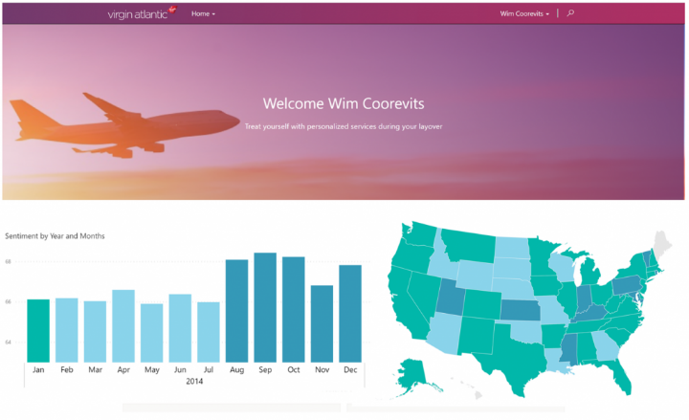

**Power Automate**

**Power Automate** lets users create automated workflows between applications and services. It helps automate repetitive business processes such as communication, data collections, and decision approvals. Don't waste important productive hours on drafting the same email for a weekly update or walking approvals through. Not only for the individual user, Power Automate allows for the creation of enter­prise-grade process automation. Power Automate's simple interface allows every level of user to auto­mate work tasks - from beginners to seasoned developers.

**Example: a purchase order approval**

Approvals are a great process to build in Power Automate. They are





**The three types of flows you can create with Power Auto­mate**

* Event driven flows
* Business process flows
* Desktop flows

**Power BI**

**Power BI** (Business Intelligence) is a business analytics service that delivers insights for analyzing data. It can share those insights through data visualizations which make up reports and dashboards to enable fast, informed decisions. Power BI scales across an organization, and it has built-in governance and security allowing businesses to focus on using data more than managing it. You can consider Power BI as the analysis and insights leg of Microsoft Power Platform. It takes business data and allows you to display it in ways that makes the most sense to users. A Power BI dashboard could potentially replace a standing meeting to report out on company metrics such as sales data, progress against goals, or employee performance.



**The parts of Power BI**

Power BI consists of a Microsoft Windows desktop application called Power BI Desktop, an

online SaaS (Software as a Service) service called the Power BI service, and mobile Power BI apps that are available on phones and tablets.

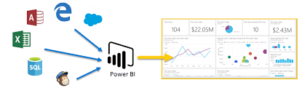

**Types of visualizations available in Power BI**

Area Charts 

Column Charts 

Line Charts 

### **Gauge charts**

### Doughnut Charts

PowerBi dashboards: -



**Power Virtual Agents**

**Power Virtual Agents** enables anyone to create powerful chatbots using a guided, no-code graphical interface, without the need for data scientists or developers. It minimizes the IT effort required to deploy and maintain a custom solution by empowering subject matter experts to build and maintain their own conversational solutions. Power Virtual Agents is part of Microsoft Power Platform, therefore integration into existing systems is streamlined with out-of-the-box integration with Power Automate and its ecosystems of hundreds of connectors. Users can enable chatbots to perform an action by simply calling a Power Automate flow. Flows help users automate activities or call back end systems. Users can utilize existing flows that have been created in their Power Apps environment or they can create a flow within Power Virtual Agents authoring canvas.





**THE PROJECTS UNDERTAKEN**

I am part of Koenig batches delivery in every mode and conducted successful training deliveries and also working as a chat moderator and moderating chats for the trainer by solving the doubts and question during training.

Successfully delivered training in London, Asia, Europe, Australia etc.

Also I am part of Microsoft azure cloud week: - Cloud computing has expanded into every aspect of business, creating new and exciting opportunities. Azure Cloud Week for Partners is designed for technical professionals to discover how Microsoft Azure can solve ever-changing customer needs.

Why to attend Azure Cloud Week for Partners?

* Learn the fundamentals of Microsoft Azure, including data platform and artificial intelligence capabilities
* Start your certification preparation with instructor-led exam prep and hands-on labs designed to help you attain role-based certifications
* Build new sales skills to help you land your next customer
* Skill up on your own time through a choice of on-demand and live trainings, offered at multiple times
* Ask questions anytime, and certified trainers will answer; the exclusive Teams channel will be available every day
* Benefits of cloud week for each track, two live training sessions will be offered each day with start times optimized for different time zones. All sessions are recorded for on-demand playback and will be available up to 30 days’ post-event, with a variety of closed-caption language options available.
* For Azure cloud week we deliver training on Cloud learn on demand platform, skill pipe platform, on24 platform.

**Future planning is for next cloud week in May and then on demand learning and other training deliveries with new technology that is on Microsoft Azure AI Fundamentals,**

**Course is AI-900. For Successfully delivering training in London, Asia, Europe, Australia etc.**

**Project Case study taken: - Bellows College**

Bellows College is an educational organization with multiple buildings on campus. Campus visitors are currently recorded in paper journals. The information is not captured consistently, and there are no means to collect and analyze data about the visits across the entire campus.

Campus administration would like to modernize their visitor registration system where access to the buildings is controlled by security personnel and all visits are required to be pre-registered and recorded by their hosts.

Throughout this project, we will build applications and perform automation to enable the Bellows College administration and security personnel to manage and control access to the buildings on campus.

Module 1: - Lab setup

**Task 1 - Acquire your Microsoft Power Platform trial tenant**

1. Copy your **Microsoft 365 credentials** from the Authorized Lab Hoster.
2. Navigate to [https://powerapps.microsoft.com](https://powerapps.microsoft.com/) and click **Start free.**
3. Under **Get started**, enter the email address from your Microsoft 365 credentials in the text box that says **Enter your work email address.**
4. You see a prompt that you have an existing account with Microsoft. Select **Sign in.**
5. Enter the password provided by the Authorized Lab Hoster and sign in.
6. Select **Yes** to stay signed in.
7. Complete your account info and select **Get started** to sign up for your Microsoft Power Platform trial.

### **Task #2 – Create environment**

1. Access [https://admin.powerplatform.microsoft.com](https://admin.powerplatform.microsoft.com/) and log in with your Microsoft 365 credentials if prompted.
2. Select **Environments** and click **+New.**
   1. For **Name**, enter **[My Initials] Practice.** (Example: AJ Practice.)
   2. For **Type**, select **Trial** (do not select the Trial (subscription-based) option).
   3. Change the toggle on **Create a database for this environment?** to **Yes.**
   4. Leave all other selections as default and click **Next.**
   5. On the next tab, leave all selections to default and click **Save.**
3. Your **Practice** environment should now show in the list of Environments.

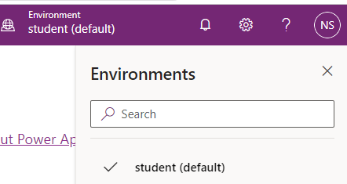

# Introduction to Microsoft Data Verse Scenario

# In this project you will access your environment, create a Microsoft Data verse database, and create a solution to track your changes. You will also create a data model to support the following requirements:

* R1 – Track information for scheduled campus visits
* R2 – Record basic information to identify and track the visitors
* R3 – Schedule, record, and manage visits

Finally, you will import sample data into Microsoft Data verse.

## **Task # 1: Create Visit Table and Columns**

The **Visit** table will contain information about the campus visits including the visitor, scheduled times and actual times of each visit.

1. Sign into [https://make.powerapps.com](https://make.powerapps.com/) (if you are not already signed in)
2. Select your **[my initials] Practice** environment at the top right if it is not already selected.
3. Using the navigation on the left, expand Dataverse, and select Tables.

Click **New table**.

1. Enter **Visit** for **Display Name**.
2. Click **Create**. This will start provisioning the table in background while you can start adding other columns.
3. Create Scheduled Start column
   1. You should be on the Visit table columns page.
   2. Make sure you have the **Columns** tab selected and click **Add column**.
   3. Enter **Scheduled Start** for **Display name**.
   4. Select **Date and Time** for **Data type**.
   5. In **Required**, select **Required**.
   6. Expand **Advanced options** section.
   7. In **Behavior**, select **Time zone independent**.
   8. Click **Done**.

7.Create Scheduled End column

* 1. Click **Add column**.
  2. Enter **Scheduled End** for **Display name**.
  3. Select **Date and Time** for **Data type**.
  4. In **Required**, select **Required**.
  5. Expand **Advanced options** section.
  6. In **Behavior**, select **Time zone independent**.
  7. Click **Done**.

8.Create Actual Start column

* 1. Click **Add column**.
  2. Enter **Actual Start** for **Display name**.
  3. Select **Date and Time** for **Data type**.
  4. In **Required**, leave this as **Optional**.
  5. Expand **Advanced options** section.
  6. In **Behavior**, select **Time zone independent**.
  7. Click **Done**.

9.Create Actual End column

* 1. Click **Add column**.
  2. Enter **Actual End** for **Display name**.
  3. Select **Date and Time** for **Data type**.
  4. In **Required**, leave this as **Optional**.
  5. Expand **Advanced options** section.
  6. In **Behavior**, select **Time zone independent**.
  7. Click **Done**.

10.Create Code column

* Click **Add column**.
* Enter **Code** for **Display name**.
* Select **Autonumber** for **Data type**.
* Select **Date prefixed number** for **Autonumber type**.
* Click **Done**.

11.Create Visitor lookup column

* Click **Add column**.
* Enter **Visitor** for **Display name**.
* Select **Lookup** for **Data type**.
* Select **Contact** for the **Related Table.**
* Expand **Advanced options** section.
* Enter **visitor_id** for **Relationship name**.
* Click **Done**.

1. Click **Save Table** in the bottom right.



# Exercise #2: Import Data

**Objective:** In this exercise you will import sample data into the Data verse database.

## **Task #1: Import the Visits.xls file.**

In this task you will import a Visit data from an Excel file.

1. You should have the **Visits.xls** file stored on your Desktop. Download [Visits.xls](https://github.com/MicrosoftLearning/PL-900-Microsoft-Power-Platform-Fundamentals/raw/master/Allfiles/Visits.xlsx) if you do not.
2. If not already signed in, sign in to [https://make.powerapps.com](https://make.powerapps.com/).
3. Select your **[my initials] Practice** environment at the top right if it is not already selected.
4. Using the navigation on the left, expand **Data verse**, and select tables.

You may see this as Data > Tables on your screen.

1. Locate and open the **Visit** table you created in the previous exercise.
2. Using the menu at the top, select the drop-down arrow next to **Data**, select the arrow next to **Get data**, and then select **Get data from Excel**.
3. From the menu that appears, select the **Upload** button.
4. Locate and select the **Visits.xls** file you downloaded earlier. (Note it can take a minute or two for the file to upload. Do not worry if you get a message that mapping errors exist, we will fix those next.)
5. Select **Map columns.**
6. Map the Columns as noted below:

| Visit Db columns | Source Values |
| --- | --- |
| Actual End | Actual end |
| Actual Start | Actual start |
| Code | Code |
| Name | Name |
| Scheduled End | Scheduled end |
| Scheduled Start | Scheduled start |

1. Leave all the rest of the fields to **Not Set**.
2. In the upper right corner of the screen, select **Save changes**.
3. On the **Import data** screen, verify that the mapping status says “Mapping was successful”.
4. Select **Import** in the upper right corner to complete the data import.

**Note:** It can take several minutes for your data to import into your table. Don’t worry if you get a few errors, that is normal, and will not impact the rest of the course

## **Task #2: Verify Data Import**

1. After your data has been imported, use the navigation at the left of the screen to select the **Visit** table again.
2. Notice that you have many tabs for the Visit table. These include Cikynns, Relationships, Business rules, Views, and more.
3. Select the **Data** tab for the Visit table. This is beneath **Tables** > **Visit**.
4. Verify that there are records in your table. You can change the view by selecting the view name at the top right and changing it to **All Columns**.

Congratulations, you have successfully created a new table and imported data.

# Started with Power Apps: How to build a canvas app

**Objective:** In this we will create a canvas app by connecting your Visits Initials table you created earlier.

# High-level lab steps

We will follow the below outline to design the canvas app:

* Create a canvas app from data in the Visit table
* Configure how the visits are shown on the browse screen
* Make some basic changes to the app Add the following columns to the forms in DetailScreen1 and EditScreen1: Actual Start, Actual End, Code, Scheduled Start, & Scheduled End
* Test the app functionality

# Exercise #1: Create Visits App

## **Task #1: Create a Visits App**

1. Navigate to [https://make.powerapps.com](https://make.powerapps.com/). You may need to authenticate - click **Sign in** and follow instructions if needed.
2. Select your **[my initials] Practice** environment at the top right if it is not already selected.
3. If necessary, click the **Home** icon on the left side of the screen. Under the **Start from** section, select **Data verse**.
4. Select your Data verse connection.

**NOTE:** If a Dataverse connection does not exist:

* + Select **New Connection**
  + Locate **Microsoft Dataverse**
  + Click **Create**

1. Locate and select the **Visits** table you created in the previous lab.
2. Select the **Connect** button in the bottom right corner.
3. After your app is created, On the Welcome to Power Apps Studio screen, check the **Don’t show me this again** box, and then select **Skip**.
4. After creation has completed, is should look like the image below.

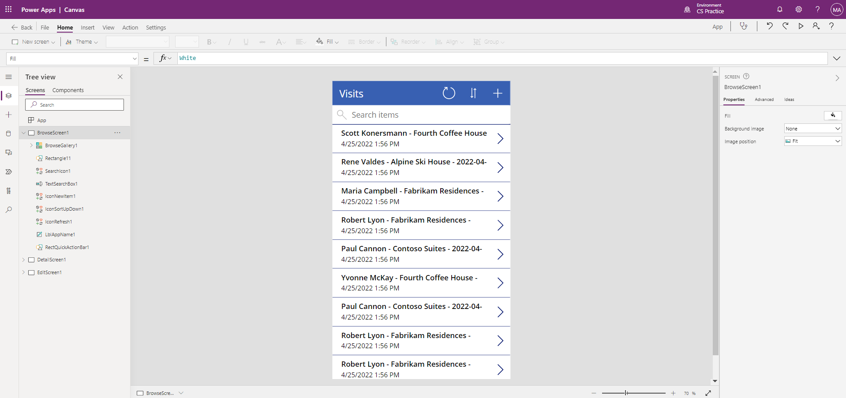

1. In the app designer, select the **preview your app** button (Play icon) on the command bar. (You can also preview the app by pressing F5 on your keyboard.) Take a look around and see how your app looks out-of-the-box.
2. Close the app preview by selecting the **X** in the upper right of the screen.

Congratulations, you have successfully created a Power App from a Dataverse table. The next step in the process is to tailor the app to match your college’s branding. The next series of steps will walk you through providing some extra customization to the app.

## **Task #2: Modify and theme the newly created app**

In this task, you will customize the header text on each of the three screens for your app (Browse, Detail, and Edit) and change the app theme.

1. You are on the Browse screen. Select the **Visits** label on the screen.
2. On the right side of the screen, under the Properties tab, update the **Text** control property to **“Bellows College Visits”**.
3. In the properties, change the **Font size** to **24**.
4. Click in the blank background to see the updated text on your Browse screen.
5. Using the navigation on the left, select **DetailScreen1**.
6. Select the **Visits** label on the screen.
7. On the right side of the screen, under the properties tab, update the **Text** control property to **“Visit Details”**.
8. Click in the blank background to see the updated text on your Details screen.
9. Using the navigation on the left, select **EditScreen1** (you may need to scroll down to see this on the Tree view).
10. Select the **Visits** label on the screen.
11. On the right side of the screen, under the properties tab, replace the text Table1 in the **Text** control property with **“Edit Details”**.
12. Click in the blank background to see the updated text on your Edit screen.
13. Using the navigation on the left, select the **BrowseScreen1**.
14. On the command toolbar, select the **Theme** button and from the list that appears select the **Red** theme color.

## **Task #3: Test your Visits app**

In this task, you will test out your new app.

1. With your application open in the App Designer, select **File**, update the name of your app to **Visits App** and select **Save**.
2. Select the **back** arrow to return to your app.
3. Using the navigation on the left, select **BrowseScreen1**.
4. In the app designer, select the **preview your app** button (Play icon) on the command bar. (You can also preview the app by pressing F5 on your keyboard.)
5. Once the app opens, in the **Search Items** field, enter the text **Maria** (Notice how the items in the gallery filter based on what is typed in the search field).
6. Once the **Contoso Suites** record for **Maria Campbell** is displayed, click on the row to navigate to open the details for that visit. (**Note**: If more than one Contoso Suites Maria Campbell record is displayed, select any of them)
7. To edit the record, select the **Pencil Icon** in the upper right corner of the app.
8. You can edit the Visit Name here and click the Checkmark icon in the top right to save the change.
9. On the top right of the screen, click the **X** Icon to return to the canvas app editor.

Congratulations! You have created and configured your first canvas app.

**Model Driven App** - As part of creating the model-driven app, you will complete the following:

* Create a new model-driven app named Campus Management
* Edit the app navigation to reference the required tables
* Customize the forms and views of the required tables for the app

We will work with the following components:

* **Views**: Views allow the user to display the existing data in the form table.
* **Forms**: This is where the user creates/updates new rows in the tables.

Both will be integrated to the model-driven app for a better user-experience.

## **Things to consider before you begin**

* What changes should we make to improve the user experience?
* What should we include in a model-driven app based on the data model we have built?
* What customizations can be made on the sitemap of a model-driven app?

# Exercise #1: Customize Views and Forms

**Objective:** In this exercise, you will customize views and forms of the custom created tables that will be used in the model-driven app.

## **Task #1: Edit Visit Form**

1. Sign in to [https://make.powerapps.com](https://make.powerapps.com/) if you are not already signed in.
2. Select your **[my initials] Practice** environment at the top right if it is not already selected.
3. Using the navigation on the left, expand **Dataverse**, select **Tables**, and click to open your **Visit** table.

If you do not see the Visit table, make sure you are in the correct environment (step 2).

1. Select the **Forms** tab and click to open the Information form with **Main** form type.

**IMPORTANT:** Since by default all forms are named Information, make sure to verify that the form you select has a Form Type of **Main** and not something else. By default, the form has two fields: Name (Primary Field) and Owner.

1. On the right side of the screen on the Properties panel, select the **Display Name** field, and change it to **Main Information**.
2. Using the menu at top of the screen, select **+ Form field** and add the following fields below the **Owner** field by dragging columns to the form or simply clicking column names:
   1. **Visitor**
   2. **Scheduled Start**
   3. **Scheduled End**
   4. **Actual Start**
   5. **Actual End**
3. Drag the **Code** column and drop it in the form header.

The header is the top right area of the form. You may need to collapse the Properties panel on the right side of the screen to see the field on the form.

1. With the **Code** field still selected, check the checkbox for **Read-only** in the Properties panel on the right side of the screen.
2. Select **Owner** field. In the Properties panel, change the **Label** to **Host**
3. Click **Save** at the top right and wait for the save to complete.
4. Click **Publish** at the top right and wait for the publishing to complete.
5. If the edit view opened in a new browser tab or window, close it. Otherwise, click **Back** at the top left of the screen. You should now be back to the Visit tables Forms Tab.

## **Task #2: Edit Active Visits view**

In this task, we will modify the default Active Visits view and create a new view for today’s visits.

1. Select the **Views** tab and click to open your **Active Visits** view.
2. Add the following fields to the view by either clicking or dragging and dropping the fields:
   1. **Code**
   2. **Visitor**
   3. **Scheduled Start**
   4. **Scheduled End**
3. Click the **Created On** column and select **Remove**. Field **Created On** will now be removed from the view.
4. Resize the individual column widths to fit the data.
5. Click **Save** and wait until the changes are saved.
6. Click **Publish** and wait for the publishing to complete.

## **Task #3: Create new view for today’s visits**

Now, we will clone the view to create a new view for today’s visits.

1. Click on the **dropdown arrow** by the Save button (be careful not to press the button itself) and select **Save As**.
2. Change the name to **Today’s Visits** and press **Save**.
3. Click **Edit filters** link in the Properties panel.
4. Click **Add**, select **Add row**.
5. Select **Scheduled Start** as a field, then select **Today** as the condition in the drop-down.
6. Click the **…** on the **Status** row and click **Delete** to delete that filter condition.
7. Press **Ok** to save the condition. The view is now filtered to show only records where the Scheduled Start date is today.
8. Add **Actual Start** and **Actual End** fields to the view.

**Note:** Since we no longer filter on the view status, we will get all today’s visits including completed ones. These fields will help to differentiate completed visits and visits in progress.

1. Click **Save**.
2. Click **Publish** and wait for the publishing to complete.

# Exercise #2: Create Model-Driven Application

**Objective:** In this exercise, you will create the model-driven app, customize the sitemap, and test the app.

For simplicity and time’s sake, we will not be addressing some of the Visit columns in this lab.

## **Task #1: Create Application**

1. Sign into [https://make.powerapps.com](https://make.powerapps.com/) (if you are not already signed in).
2. Select your **[my initials] Practice** environment at the top right if it is not already selected.
3. Create the Model-Driven Application:
   1. Select **Blank app** in the **Start from** section of the Home screen.
   2. Under **Blank app based on Dataverse**, select **Create**.
   3. Select the **Modern app designer** experience.
   4. Select **Create**.
   5. Enter **Bellows Campus Management** for Name and select **Create**.
4. After your new model-driven application loads, select the **+ Add Page** button.
5. On the Add Page screen, choose **Table based view and form**, and then select the **Next** button.
6. Add the following tables:
   1. Visit
   2. Contact
7. After you have selected the 2 tables, select **Add**.
8. Using the navigation icons on the left side of the screen, select **Navigation**.
9. In the Navigation Pane, select **Group 1** below where it says Navigation bar.
10. On the right side of the screen, in the **Display Options** section, change the **Title** property to **Security**.

## **Task #2: Edit your app**

Now that we have all the necessary components added to your model-driven application, we will now organize items.

1. In the Navigation Pane, under the security group, select **SubArea1**.
2. Select the **Ellipsis**, and from the menu that appears, select remove **SubArea1**.
3. Using the navigation on the left side of the screen, select **Pages**.
4. Locate and expand **Visit** on the Pages pane.
5. Select **Visit form**.
6. On the right side of the screen, select **Manage Forms**.
7. Select the **Main Information** form, and then click **Save**.
8. Under **Visit** on the Pages pane, select **Visit view**.
9. On the right side of the screen, select **Manage views**.
10. Select the **Today’s Visits** and **Active Visits** forms, then select **Save**.
11. Select **Save**.
12. Once the **Save** is complete, select the **Publish** button to publish your changes.

## **Task #3: Test Application**

1. Start the application
   1. Select **Play** to open your app in a new window.
2. Create new Contact
   1. The app should open to the **My Active Contacts** view. If it does not, select Visits on the left.
   2. Click **New** from the top menu.
   3. Provide **First Name** as John and **Last Name** as Doe.
   4. Provide your personal email as **Email**. This will be used in a future lab where you will receive an email.
   5. Click **Save and Close**.
   6. You should now see the created contact on the **Active Contacts** view.
3. Create new Visit
   1. Select **Visits** from the sitemap.
   2. Click **New**.
   3. Enter the fields as following
      1. **Name**: New test visit
      2. **Visitor**: select John Doe
      3. **Scheduled Start**: select tomorrow’s date and 2:00 PM as start time
      4. **Scheduled End**: select tomorrow’s date and 3:30 PM as end time
   4. Click **Save and Close**. This will create the Visit and you should be able to see it on the Active Visits View.
   5. Change view to **Today’s Visits**. You should no longer see the new visit in the view, since it is scheduled for tomorrow.
4. You may add more test records.

Your running app should look approximately like the following:

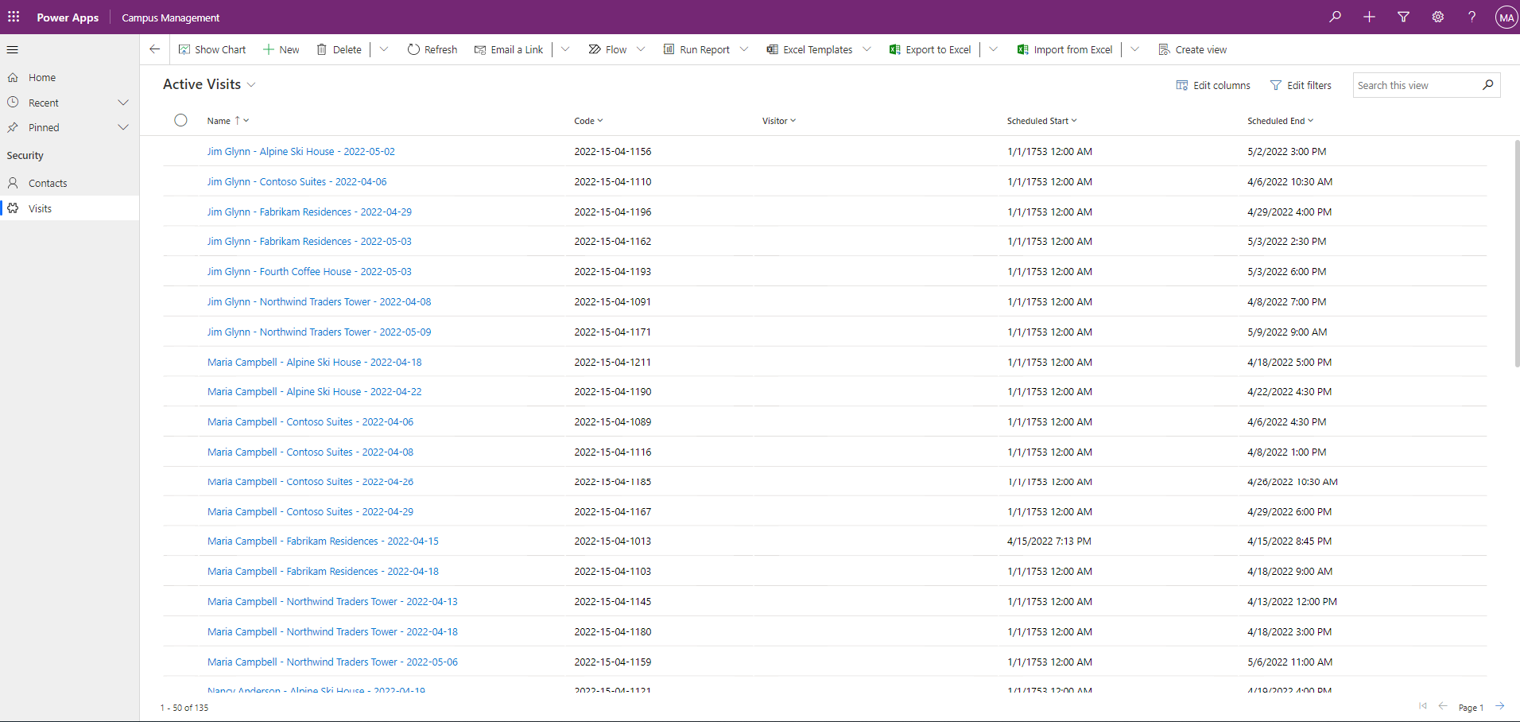

Congratulations! You have created and configured your first model-driven app.

# Started with Power Automate to build an automated solution

# High-level lab steps

# The following have been identified as requirements you must implement to complete the project:

* Contacts need to be notified via email when a visit is scheduled.
* John Doe contact created with a personal email address populated.

# Exercise #1: Create Visit Notification flow

**Objective:** In this you will create a Power Automate flow that implements the requirement. The visitor should be sent an email that includes the unique code assigned to the visit when a visit is created.

## **Task #1: Create a flow**

1. Navigate to [https://make.powerapps.com](https://make.powerapps.com/). You may need to reauthenticate - click **Sign in** and follow instructions if needed.
2. Select your **[my initials] Practice** environment at the top right if it is not already selected.
3. In the left navigation, select **Flows**.
4. If prompted, select **Get started**.
5. Click **New flow** and select **Automated cloud flow**.
6. Enter “Visit Notification” for **Flow name**.
7. In **Choose your flow’s trigger**, search for **Dataverse**.
8. Select the trigger **When a row is added, modified or deleted**, and then click **Create**.
9. Populate the trigger conditions for the flow:
   1. Select **Added** for **Change type**
   2. Select **Visits** for **Table name**
   3. Select **Organization** for **Scope**
   4. On the trigger step, click the ellipsis (**…**) and click **Rename**. Rename this trigger **“When a visit is added”**. This is a good practice, so you and other flow editors can understand the purpose of the step without having to dive into the details.

## **Task #2: Create a step to get the visitor row**

1. Select **New Step**. This step is required to retrieve visitors information, including email address.
2. Search for **Dataverse**.
3. Select the **Get a row by ID** action.
4. Select **Contacts** as **Table name**
5. Select the **Row ID** field. Notice that a window pops up to select Dynamic content or Expressions.
6. In the **Row ID** field, select **Visitor (Value)** from the Dynamic content list. In this step, you are looking up the Contact for the Visit row that was created to trigger this flow. Since email address is part of the Contact table, you will need this information to send the email to the visitor.
7. On this action, click the ellipsis (**…**) and click **Rename**. Rename this action **“Get the Visitor”**. This is a good practice, so you and other flow editors can understand the purpose of the step without having to dive into the details.

## **Task #3: Create a step to send an email to the visitor**

1. Click **New Step**. This is the step that will send an email to the visitor.
2. Search for mail, select **Office 365 Outlook** connector and **Send an email (V2)** action.
3. If asked to Accept terms and conditions for using this action, click **Accept**.
4. Select **Add dynamic content** under the **To** field.
5. Select **Email** from the Dynamic content list. > Notice that it is beneath the **Get the visitor** header. This means you are selecting the Email that is related to the Visitor that you looked up in the previous step.
6. Enter **Your scheduled visit to Bellows College** in the **Subject** field.
7. Enter the following text in **Email Body**:

Dynamic content needs to be placed where fields are named in brackets. It is recommended to copy & paste all text first and then add dynamic content in the correct places.

Dear {First Name},

You are currently scheduled to visit Bellows Campus from {Scheduled Start} until {Scheduled End}.

Best regards,

Campus Administration

Bellows College

1. Highlight the **{First Name}** text. Replace it with the **First Name** field from the **Get the Visitor** step.
2. Highlight the **{Scheduled Start}** text. Replace it with the **Scheduled Start** field **When a visit is added** step.
3. Highlight the **{Scheduled End}** text. Replace it with the **Scheduled End** field from the **When a visit is added** Step.
4. Click **Save**.

Leave this flow tab open for the next task. You flow should look approximately like the following:

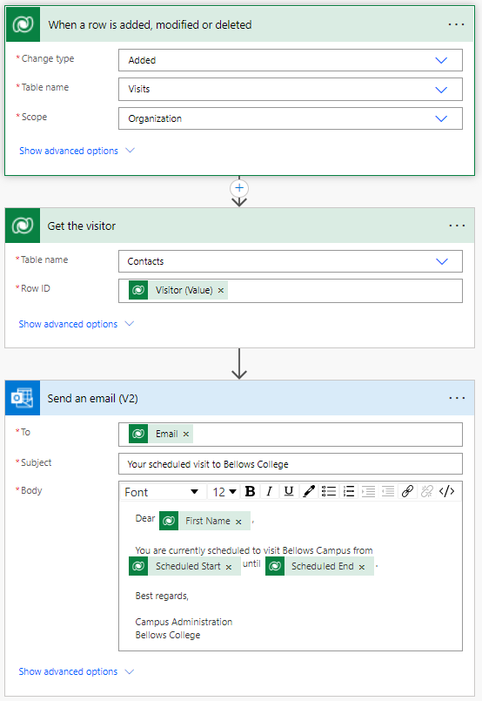

## **Task #4: Validate and test the flow**

1. Open a new tab in your browser and navigate to [https://make.powerapps.com](https://make.powerapps.com/).
2. Select your **[my initials] Practice** environment at the top right if it is not already selected.
3. Click **Apps** and select the **Campus Management Model-driven** app you created earlier.
4. Leaving this browser tab open, navigate back to the previous tab with your flow.
5. On the command bar, click **Test**. Select **Manually** and then click **Test**.
6. Navigate to the browser tab with your model-driven app open.
7. Using the navigation on the left, select **Visits**
8. Press the **+ New** button to add a new **Visit** record.
9. Complete the Visit record as follows:
   * **Name:** Test Visit
   * **Visitor:** John Doe
   * **Scheduled Start:** Tomorrow at 8:00 AM
   * **Scheduled End:** Tomorrow at 9:00 AM
10. Select the **Save and Close** button.
11. Navigate to the browser tab with your flow test running. After a short delay, you should see the flow running. This is where you can catch any issues in the flow or confirm that it ran successfully.

After a short delay, you should see an email in your inbox, since you populated John Doe’s email as your personal email. Note that it may go to your Junk Email folder.

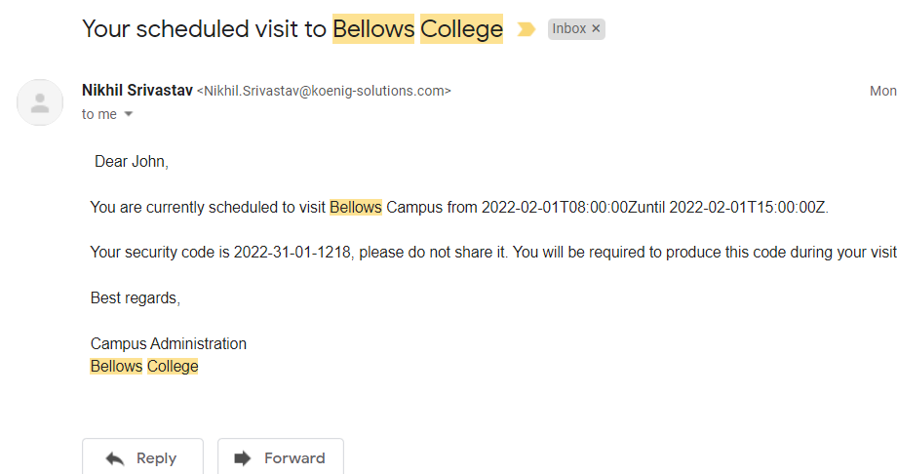

# Started with Power BI: How to build a simple dashboard

# 

# High-level lab steps

We will follow the below steps to design and create a Power BI dashboard:

* Connect to Dataverse
* Transform the data to include user-friendly descriptions for the related rows (lookups)
* Create and publish a report with various visualizations of the campus visits information
* Utilize a user natural language query to build additional visualizations
* Build a mobile view of the Power BI dashboard



## **Things to consider before you begin**

* Who is the target audience of the report?
* How will the audience consume the report? Typical device? Location?
* Do you have sufficient data to visualize?
* What are the possible characteristics you can use to analyze data about the visits?

# Exercise #1: Create Power BI Report

**Objective:** In this exercise, you will create a Power BI report based on data the Excel spreadsheet we leveraged in a previous exercise.

## **Task #1: Prepare Power BI service**

1. Download [visits.pbix](https://github.com/MicrosoftLearning/PL-900-Microsoft-Power-Platform-Fundamentals/raw/master/Allfiles/visits.pbix) and save on your computer.
2. Navigate to <https://app.powerbi.com/> and sign in if needed.
3. In the lower Left corner of the screen, select **Get Data**
4. Select the **Get** button under **Files**, in the **Create new content** section.
5. Select **Local File**.
6. Locate and select **visits.pbix** file you’ve downloaded earlier.
7. Once data load is complete, select **visits** report (notice that the Type is set to **Report**).
8. Click **Edit**. If **Edit** menu item is not visible click **…** and then select **Edit**.

You have now setup Power BI service to use for your labs.

## **Task #2: Create Chart and Time Visualizations**

1. Press the **Pie chart** icon in the **Visualizations** panel to insert a chart.
2. Press the drop-down arrow beside **bc_name** in the Fields pane. Drag the **Building** field and drop it into **Legend** box.
3. Press the drop-down arrow beside **bc_Visit** in the Fields pane. Drag the **Visit** field and drop it into **Values** box.
4. Resize the pie chart using corner handles so that all chart components are visible.
5. Click on the report outside of the pie chart to deselect it and select stacked column chart in **Visualizations** pane.
6. Press the drop-down arrow beside **bc_Visit** in the Fields pane. Drag the **Visit** field and drop it into **Values** box.
7. Drag **Start** field and drop it into **Axis** target box.
8. In the Visualizations pane, click **x** next to **Year** and **Quarter** to leave only **Month** and **Day** totals for the Axis.
9. Resize the chart as desired using the corner handles.
10. Test the report interactivity:
    1. Click various building slices on the pie chart and observe changes on the time report.
    2. Click on the column chart. Press the down arrow to turn on **Drill down** mode (or right click on the chart and select **Drill down**), then click a column to drill down to the next level (days).
    3. Drill up and down and select various bars on the time column chart to observe changes on the pie report.
11. Save work in progress by pressing **Save**.

# Exercise #2: Create Power BI Dashboard

## **Task #1: Create Power BI Dashboard**

1. You should have the report open from the previous task.
2. Select **Pin to a dashboard** on the menu. Depending on the layout you may need to press **…** to show additional menu items.
3. Select **New dashboard** on **Pin to dashboard** prompt.
4. Enter **Campus Management** as a **Dashboard name**, press **Pin live**.
5. Select **My workspace** at the top, select **[Your Last Name] Campus Management** dashboard.
6. A pop-up will prompt you that the dashboard has been created. Select **Go to dashboard**.
7. Test interactivity of the pie and bar charts displayed.

## **Task #2: Add Visualizations Using Natural Language**

1. Within your **Campus Management** dashboard, select **Ask a question about your data** bar at the top.
2. Enter **buildings by number of visits** in Q&A area. A bar chart will be displayed.
3. Select **Pin visual**.
4. Select **Existing dashboard**, select your **Campus Management** dashboard, press **Pin**.
5. Click **Exit Q&A**.

Your **Campus Management** dashboard should be displayed with three visuals on it. You may have to scroll down to see the new Q&A visual.

Your dashboard should look similar to the following:

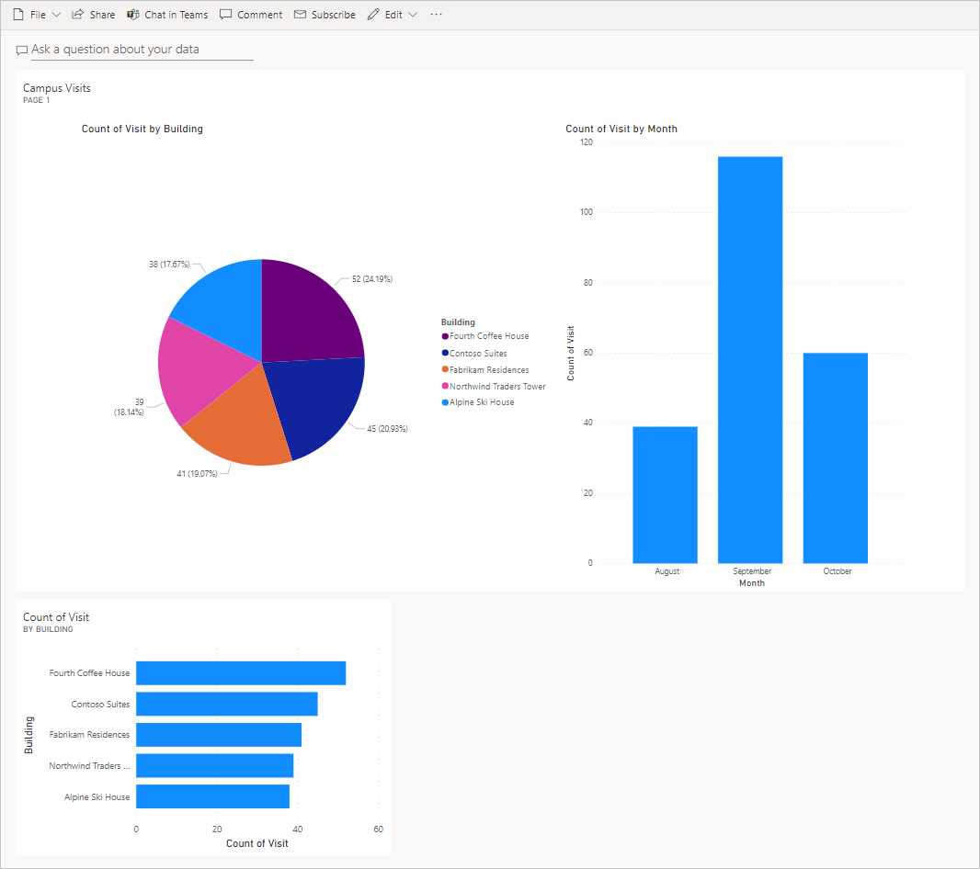

**Microsoft Azure AI Fundamentals**

This exam is an opportunity to demonstrate knowledge of machine learning (ML) and artificial intelligence (AI) concepts and related Microsoft Azure services. Candidates for this exam should have familiarity with Exam AI-900’s self-paced or instructor-led learning material.

This exam is intended for candidates with both technical and non-technical backgrounds. Data science and software engineering experience are not required; however, awareness of cloud basics and client-server applications would be beneficial.

Azure AI Fundamentals can be used to prepare for other Azure role-based certifications like Azure Data Scientist Associate or Azure AI Engineer Associate, but it is not a prerequisite for any of them.

Learning Modules: -

* Describe Artificial Intelligence workloads and considerations.
* Describe fundamental principles of machine learning on Azure.
* Describe features of computer vision workloads on Azure.
* Describe features of Natural Language Processing (NLP) workloads on Azure.



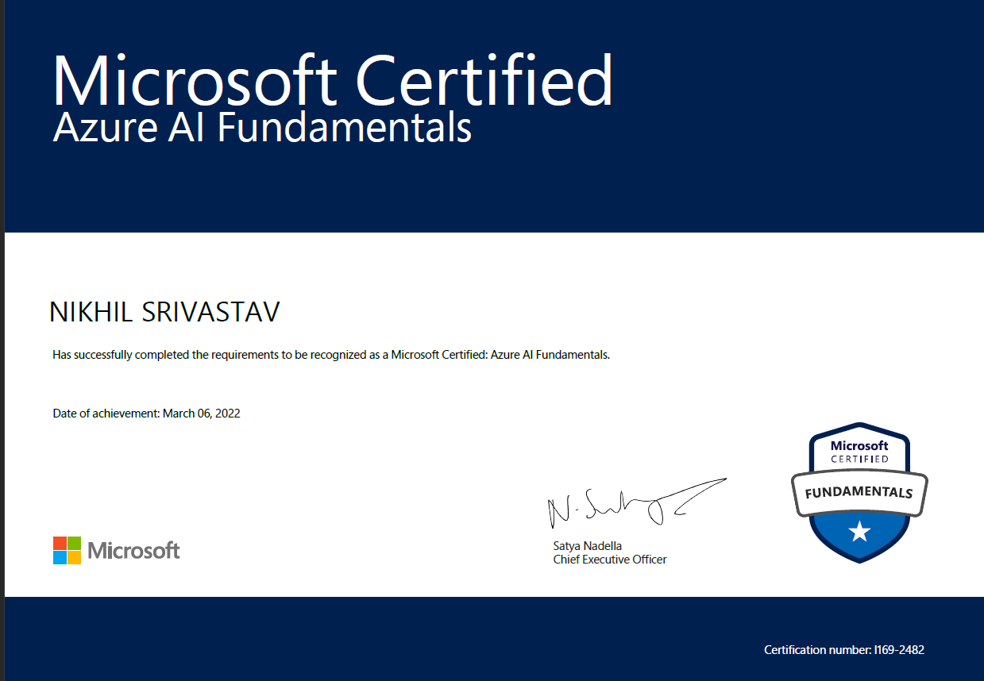

**Introduction to AI**

**What is Artificial Intelligence?**

AI enables us to build amazing software that can improve health care, enable people to overcome physical disadvantages, empower smart infrastructure, create incredible entertainment experiences, and even save the planet! Simply put, AI is the creation of software that imitates human behaviors and capabilities.

Key elements include:

* Making decisions based on data and past experience
* Detecting anomalies
* Interpreting visual input
* Understanding written and spoken language
* Engaging in dialogs and conversations

**Common Artificial Intelligence Workloads**

Common AI-related workloads include:

* **Machine learning** - This is often the foundation for an AI system, and is the way we “teach” a com­puter model to make prediction and draw conclusions from data.
* **Anomaly detection** - The capability to automatically detect errors or unusual activity in a system.
* **Computer vision** - The capability of software to interpret the world visually through cameras, video, and images.
* **Natural language processing** - The capability for a computer to interpret written or spoken lan­guage, and respond in kind.
* **Knowledge mining** - The capability to extract information from data sources to create a searchable knowledge store.

**Why we need Azure basics?**

Microsoft Azure provides a scalable, reliable cloud platform for AI, including:

1. **Data storage**: Azure Storage offers highly available, scalable, and secure storage for a variety of data objects in the cloud.
2. **Compute**: Azure cloud compute provides the infrastructure to run applications and scale capacity on demand. A compute target is a designated compute resource or environment.
3. **Services**: Azure services are delivered over the internet in a pay-as-you-go model. Services include servers, storage, databases, networking, software, analytics, and intelligence. You can learn more about **Azure services**2 here.

**Machine Learning**

**Introduction to Machine Learning**

Machine Learning is the foundation for most AI solutions, and enables the creation of models that predict unknown values and infer insights from observed data.

So how do machines learn?

The answer is, from data. In today's world, we create huge volumes of data as we go about our everyday lives. From the text messages, emails, and social media posts we send to the photographs and videos we take on our phones, we generate massive amounts of information. More data still is created by millions of sensors in our homes, cars, cities, public transport infrastructure, and factories.

Data scientists can use all of that data to train machine learning models that can make predictions and inferences based on the relationships they find in the data.

**Types of machine learning**

There are two general approaches to machine learning, supervised and unsupervised machine learning. Both have a goal of capturing a model, or equation, that will try to predict a result, or *label*, that is as close to the actual result as possible.

Both approaches require an input of data. We call different groups of data, *features*.

***Supervised machine learning*** relies on us having some data with known label values that we can fit to a model, which can then be applied to new data for which we don’t have the label values. Labels are what we want to predict, such as house price, an item in an image, or if someone has diabetes.

Two types of supervised machine learning tasks include:

* **Regression**: used predict a continuous numeric value; like a price, a sales total, or some other meas­ure.
* **Classification**: used to determine the probability between 0 and 1 data belongs to a particular group, or class.

***Unsupervised machine learning*** is an approach that trains a model to separate items only based on their features. There is no previously known cluster value, or label, from which to train the model.

1. **Clustering**: used to determine a label based on how similar the item is to the items in the label group.

**Azure Machine Learning Designer**

In Azure Machine Learning, multi-step workflows to prepare data, train models, and perform model management tasks are called pipelines. The *designer* tool in Azure Machine Learning studio enables you to create and run pipelines by using a drag & drop visual interface to connect modules that define the steps and data flow for the pipeline.

**A step process for designer: -**



**Computer Vision Concepts**

**What is Computer Vision?**

*Computer vision* is one of the core areas of artificial intelligence (AI), and focuses on creating solutions that enable AI-enabled applications to “see” the world and make sense of it.

Of course, computers don't have biological eyes that work the way ours do, but they are capable of processing images; either from a live camera feed or from digital photographs or videos. This ability to process images is the key to creating software that can emulate human visual perception.

To an AI application, an image is just an array of pixel values. These numeric values can be used as *features* to train machine learning models that make predictions about

**Computer Vision Services**

* **Object detection**
* **Form recognizer**
* **Image classification etc**
* **Text classification**
* **Optical character Recognition**

**Natural Language Processing**

**What is Natural Language Processing?**

Natural language processing (NLP) is the area of AI that deals with creating software that understands written and spoken language.

NLP enables you to create software that can:

* Analyze text documents to extract key phrases and recognize entities (such as places, dates, or people).
* Perform *sentiment analysis* to determine how positive or negative the language used in a document is.
* Interpret spoken language, and synthesize speech responses.
* Automatically translate spoken or written phrases between languages.
* Interpret commands and determine appropriate actions

**Azure Bot Service**

**Provisioning Azure resources**

You can use the following resource to access this service:

**Language**: A resource that enables you to build apps with industry-leading natural language under­standing capabilities without machine learning expertise.

**Azure Bot Service**

After you've created and published a knowledge base, you can use Azure Bot Service deliver it to users through a bot.

**Extend and configure the bot**

After creating your bot, you can manage it in the Azure portal, where you can:

Extend the bot's functionality by adding custom code.

Test the bot in an interactive test interface.

Configure logging, analytics, and integration with other services.

**Connect channels** When your bot is ready to be delivered to users, you can connect it to multiple *channels*; making it possible for users to interact with it through web chat, email, Microsoft Teams, and other common communication media.

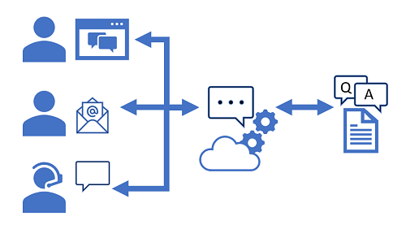

Project – Image analysis Analyze images with the Computer Vision service

The Computer Vision cognitive service uses pre-trained machine learning models to analyze images and extract information about them.

For example, suppose the fictitious retailer Northwind Traders has decided to implement a "smart store", in which AI services monitor the store to identify customers requiring assistance, and direct employees to help them. By using the Computer Vision service, images taken by cameras throughout the store can be analyzed to provide meaningful descriptions of what they depict.

In this we will use a simple command-line application to see the Computer Vision service in action. The same principles and functionality apply in real-world solutions, such as web sites or phone apps.

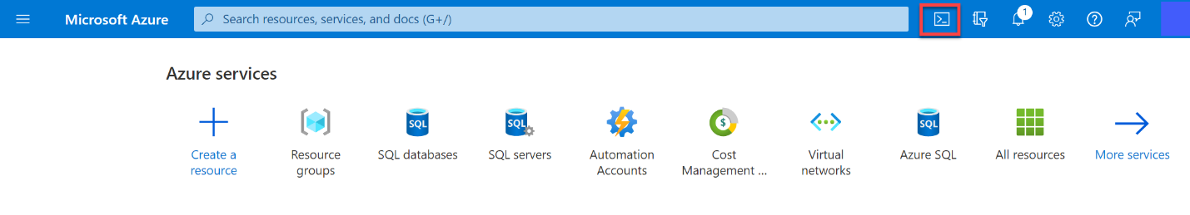

Steps: -

* Create a Cognitive Services resource
* You can use the Computer Vision service by creating either a **Computer Vision** resource or a **Cognitive Services** resource.
* If you haven't already done so, create a **Cognitive Services** resource in your Azure subscription.
* In another browser tab, open the Azure portal at [https://portal.azure.com](https://portal.azure.com/), signing in with your Microsoft account.
* Click the **＋Create a resource** button, search for Cognitive Services, and create a **Cognitive Services** resource with the following settings:
* **Subscription**: Your Azure subscription.
* **Resource group**: Select or create a resource group with a unique name.
* **Region**: Choose any available region:
* **Name**: Enter a unique name.
* **Pricing tier**: S0

**I confirm I have read and understood the notices**: Selected.

Review and create the resource, and wait for deployment to complete. Then go to the deployed resource.

View the **Keys and Endpoint** page for your Cognitive Services resource. You will need the endpoint and keys to connect from client applications.

* Run Cloud Shell
* To test the capabilities of the Computer Vision service, we'll use a simple command-line application that runs in the Cloud Shell on Azure.

In the Azure portal, select the **[>_]** (Cloud Shell) button at the top of the page to the right of the search box. This opens a Cloud Shell pane at the bottom of the portal

The first time you open the Cloud Shell, you may be prompted to choose the type of shell you want to use (Bash or PowerShell). Select **PowerShell**. If you do not see this option, skip the step.

If you are prompted to create storage for your Cloud Shell, ensure your subscription is specified and select **Create storage**. Then wait a minute or so for the storage to be created.

Make sure the type of shell indicated on the top left of the Cloud Shell pane is switched to PowerShell. If it is Bash, switch to PowerShell by using the drop-down menu.

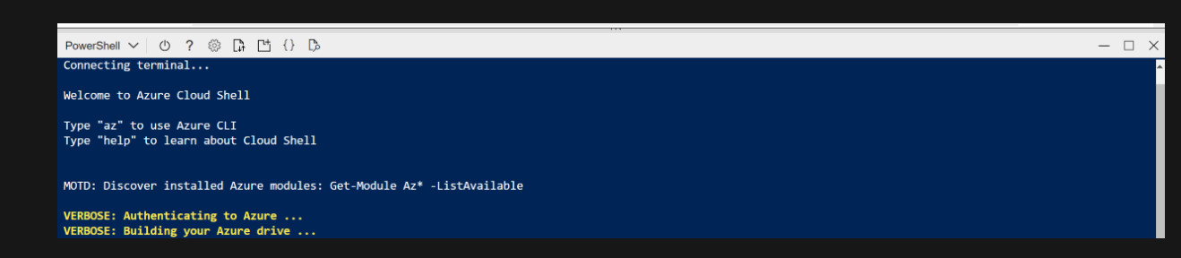

Wait for PowerShell to start. You should see the following screen in the Azure portal

Configure and run a client application

Now that you have a Cloud Shell environment, you can run a simple application that uses the Computer Vision service to analyze an image.

In the command shell, enter the following command to download the sample application and save it to a folder called ai-900.

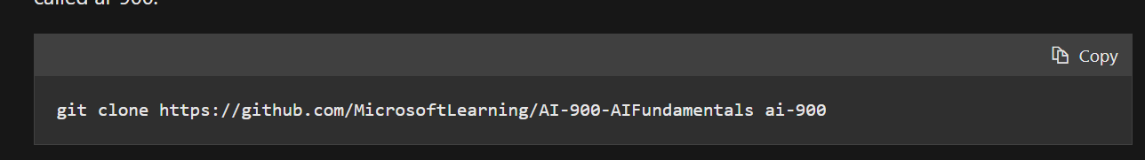

Copy -git clone https://github.com/MicrosoftLearning/AI-900-AIFundamentals ai-900

The files are downloaded to a folder named **ai-900**. Now we want to see all of the files in your Cloud Shell storage and work with them. Type the following command into the shell.

In the **Files** pane on the left, expand **ai-900** and select **analyze-image.ps1**. This file contains some code that uses the Computer Vision service to analyze an image, as shown here:

Don't worry too much about the code, the important thing is that it needs the endpoint URL and either of the keys for your Cognitive Services resource. Copy these from the **Keys and Endpoints** page for your resource from the Azure portal and paste them into the code editor, replacing the **YOUR_KEY** and **YOUR_ENDPOINT** placeholder values respectively.

 Tip

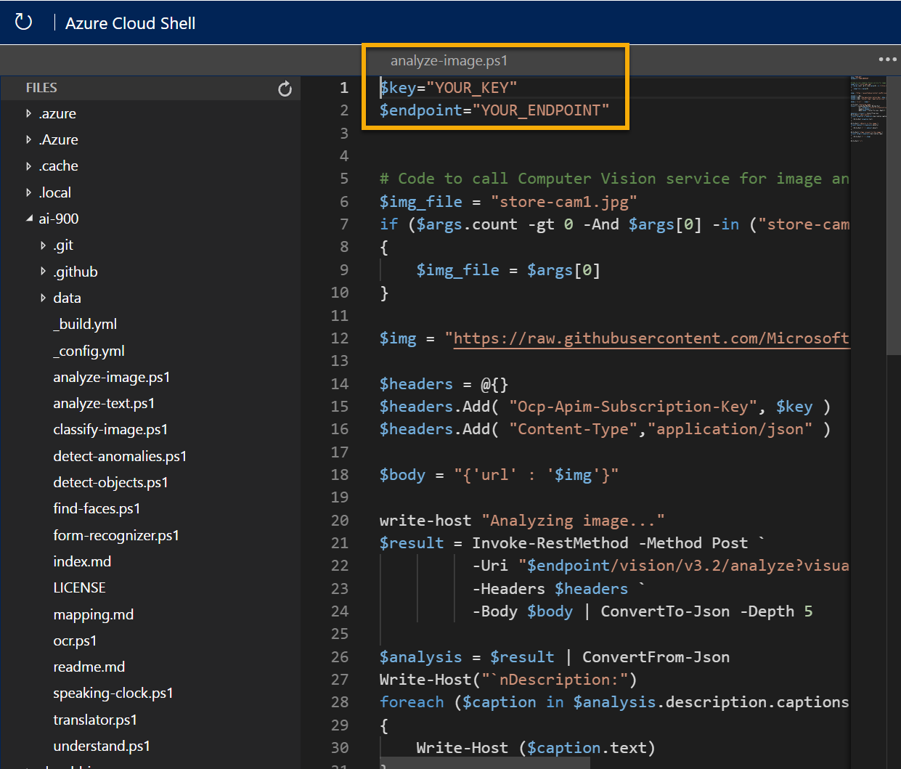

You may need to use the separator bar to adjust the screen area as you work with the **Keys and Endpoint** and **Editor** panes.

After pasting the key and endpoint values, the first two lines of code should look similar to this:

PowerShellCopy

$key="1a2b3c4d5e6f7g8h9i0j...."

$endpoint="https..."

At the top right of the editor pane, use the **...** button to open the menu and select **Save** to save your changes.

The sample client application will use your Computer Vision service to analyze the following image, taken by a camera in the Northwind Traders store:



To analyze the second image, enter the following command:

Copy ./analyze-image.ps1 store-camera-2.jpg

🡪Review the results of the image analysis for the second image.

🡪Tags: **Water**100% confidence ,**Sky**100% confidence,**Lake**95% confidence,**Outdoor**95% confidence,**Skyscraper**89% confidence,**Reflection**61% confidence,**Overlooking**33% confidence

**Day**12% confidence

🡪Description: a city skyline with water 27% confidence , Racy Content:False75% confidence,Adult Content: False78% confidence.

**Analyze text**

Natural Language Processing (NLP) is a branch of artificial intelligence (AI) that deals with written and spoken language. You can use NLP to build solutions that extracting semantic meaning from text or speech, or that formulate meaningful responses in natural language.

Microsoft Azure Cognitive Services includes the text analytics capabilities in the Language service, which provides some out-of-the-box NLP capabilities, including the identification of key phrases in text, and the classification of text based on sentiment.

## Run Cloud Shell

To test the text analytics capabilities of the Language service, we'll use a simple command-line application that runs in the Cloud Shell on Azure.

1. In the Azure portal, select the **[>_]** (Cloud Shell) button at the top of the page to the right of the search box. This opens a Cloud Shell pane at the bottom of the portal.



1. The first time you open the Cloud Shell, you may be prompted to choose the type of shell you want to use (Bash or PowerShell). Select **PowerShell**. If you do not see this option, skip the step.
2. If you are prompted to create storage for your Cloud Shell, ensure your subscription is specified and select **Create storage**. Then wait a minute or so for the storage to be created.

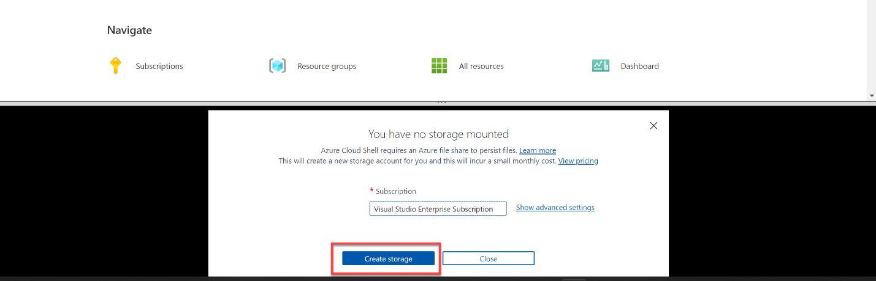

Make sure the type of shell indicated on the top left of the Cloud Shell pane is switched to PowerShell. If it is Bash, switch to PowerShell by using the drop-down menu.

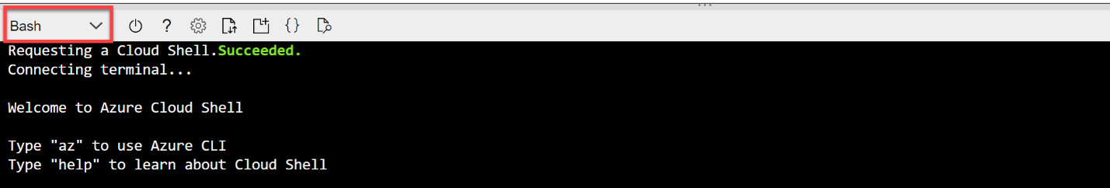

Wait for PowerShell to start. You should see the following screen in the Azure portal:

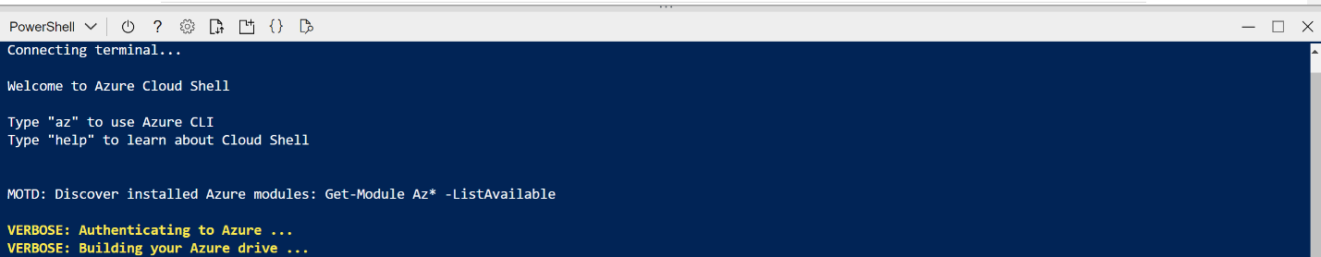

**Steps: -**

## Configure and run a client application

Now that you have a custom model, you can run a simple client application that uses the Language service.

1. In the command shell, enter the following command to download the sample application and save it to a folder called ai-900.

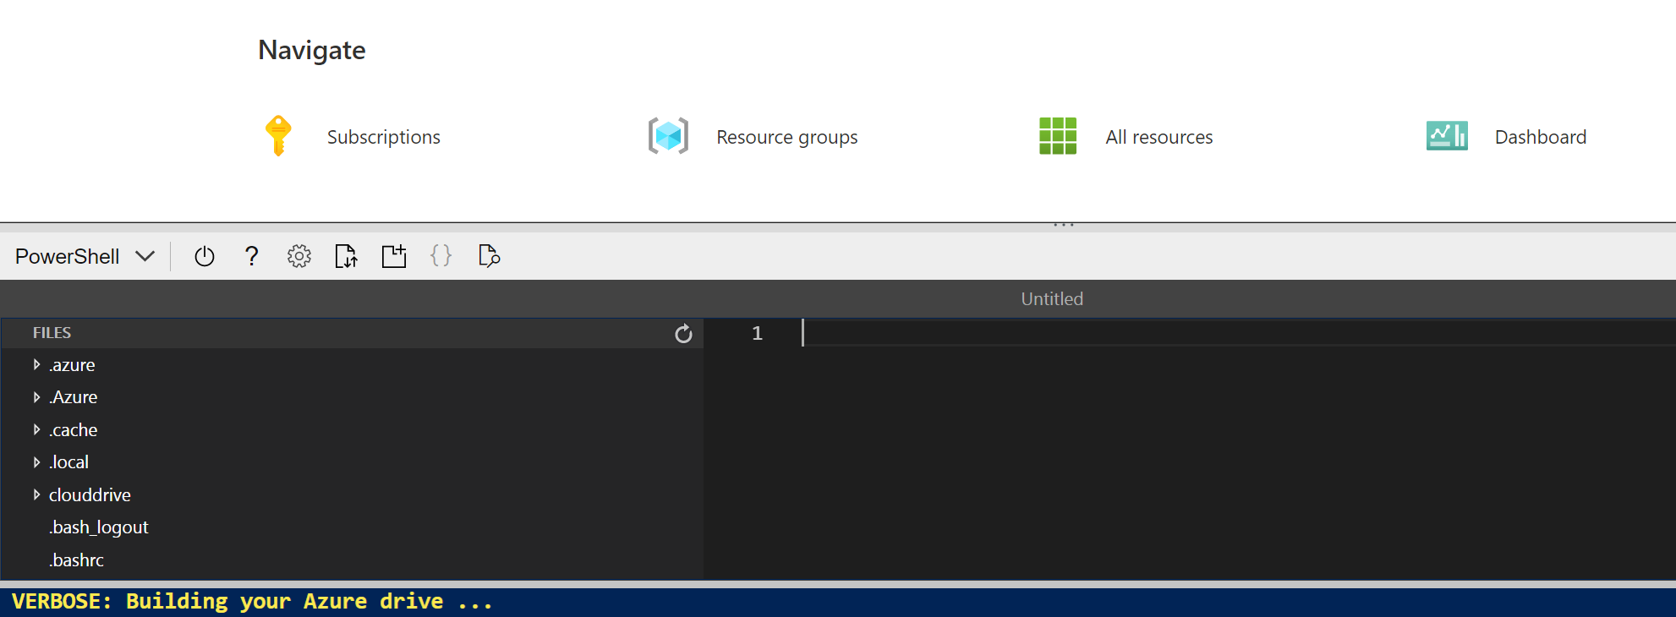

**You will need Key and Endpoint.**

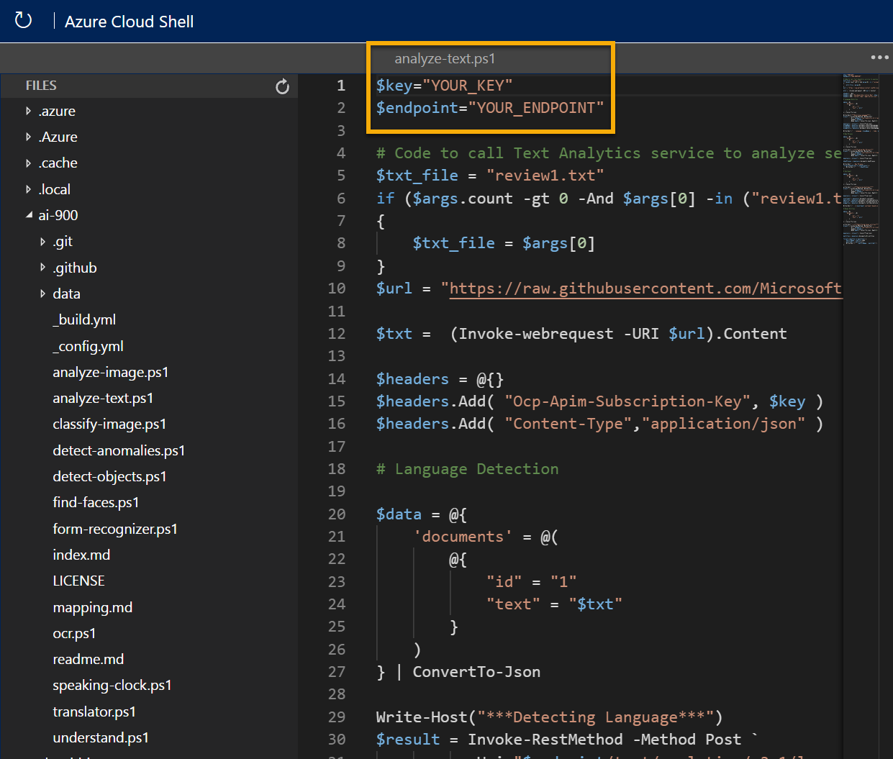

**Copy key and endpoint**

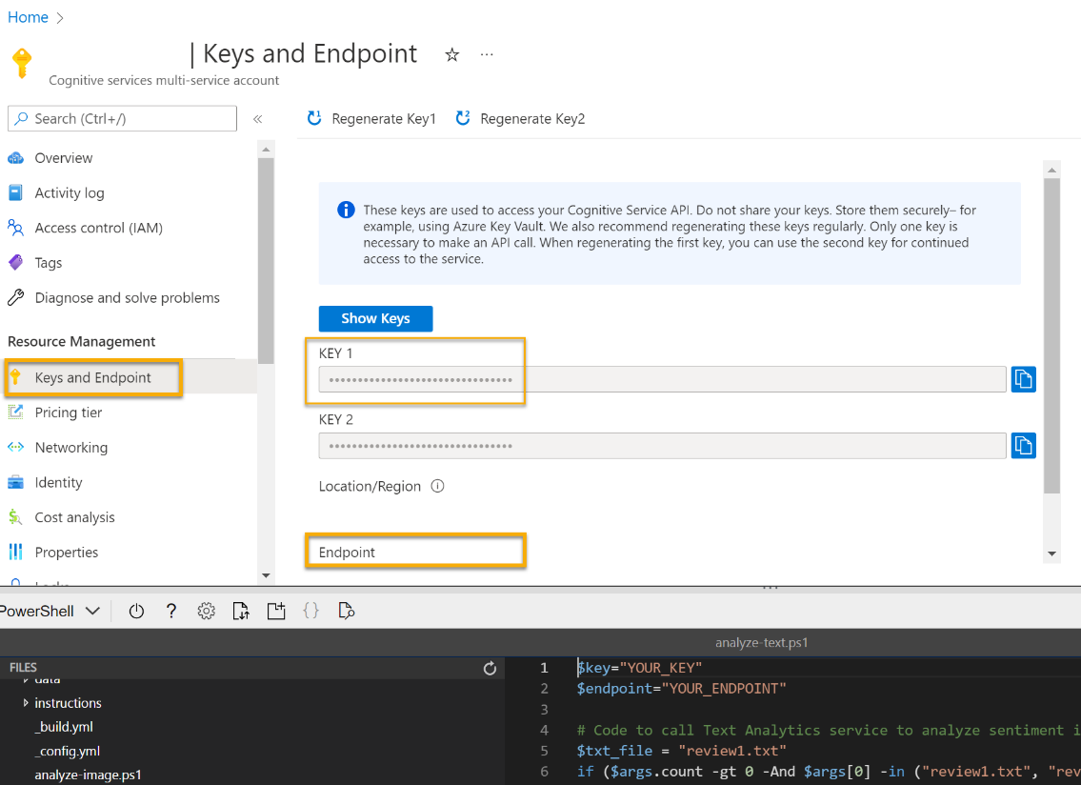

Place key and Endpoint.

$key="1a2b3c4d5e6f7g8h9i0j...."

$endpoint="https..."

Good Hotel and staff The Royal Hotel, London, UK 3/2/2018 Clean rooms, good service, great location near Buckingham Palace and Westminster Abbey, and so on. We thoroughly enjoyed our stay. The courtyard is very peaceful and we went to a restaurant which is part of the same group and is Indian ( West coast so plenty of fish) with a Michelin Star. We had the taster menu which was fabulous. The rooms were very well appointed with a kitchen, lounge, bedroom and enormous bathroom. Thoroughly recommended.

**CONCLUSION**

During this training at Koenig solutions learning, I am learning professionalism, teamwork, industrial robust development standards and business interactions. Working on a real-world application of scale has improved my judgmental abilities while keeping core agile software engineering tactics in mind. This experience has helped me watch and learn how the cycle of Training and analysis works. I have observed the whole journey of Training and development.

Beyond software development, I have learned to give utmost importance to performance and hardware integration of an environment. I as a user expect freedom for my own devices. This freedom of using product allows users to expect something more from the product. This passion to explore more gives rise to the demand from the user's end.

This demand is received by Feedback teams. The continuous communication to clients establishes the trust and ease at which clients can demand a feature. Later on after discussion and customers need trainer are allocated they advise on course take and also give demos.

The level of understanding and handling of large applications and training batches is what I achieved during this period. This job has helped me grow from just a developer to an innovator and help bring my ideas into reality by looking at a holistic perspective of the product life cycle.

Benefits of using Microsoft Power Platform Benefits for Your Organization

* Self-Service for Easy Adoption and Use
* Streamlines Processes and Improves Productivity
* Facilitates Remote Work and Collaboration
* Takes advantage of the oncoming AI revolution
* All Enterprise Business Processes in a Single Platform

BIBLIOGRAPHY: -

[*https://docs.microsoft.com/en-us/learn/certifications/power-platform-fundamentals/*](https://docs.microsoft.com/en-us/learn/certifications/power-platform-fundamentals/)

[*https://en.wikipedia.org/wiki/Main_Page*](https://en.wikipedia.org/wiki/Main_Page)

[*https://powerapps.microsoft.com/en-in/*](https://powerapps.microsoft.com/en-in/)

[*https://powerbi.microsoft.com/en-au/*](https://powerbi.microsoft.com/en-au/)

[*https://powervirtualagents.microsoft.com/en-us/*](https://powervirtualagents.microsoft.com/en-us/)

[*https://powerautomate.microsoft.com/en-in/*](https://powerautomate.microsoft.com/en-in/)

[*https://microsoftlearning.github.io/PL-900-Microsoft-Power-Platform-Fundamentals/*](https://microsoftlearning.github.io/PL-900-Microsoft-Power-Platform-Fundamentals/)

<https://microsoftlearning.github.io/AI-900-AIFundamentals/>

*A video demo is available at the following link: https://customers.microsoft.com/en-us/story/766053-heathrow-airport-travel-transportation-power-apps*

*A video demo is available at the following link: https://www.microsoft.com/en-us/videoplayer/embed/RE4mERh*

*A video demo is available at the following link:* <https://www.microsoft.com/en-us/videoplayer/embed/RE4mERi>